What Problem Are We Solving?
Today, creating a test in INGenious still depends on a person doing the manual work — for both web and API.
For web, INGenious can convert recorded Playwright steps into test cases, but a tester first has to sit at the browser and record every flow by hand — clicking through each screen for every new feature. The tool automates the conversion, not the exploration.
For API, building test cases means manually setting up each request, header, payload, and assertion — even when the API is already fully described in a Swagger document or available as a live endpoint.
In both cases, the knowledge of what to test usually already exists — in a written requirement, an Azure Test Plan, or an API spec — yet it still has to be re-built by hand.

Where It Applies
The everyday test-authoring workflow in INGenious, across both web UI and API testing.

Who's Affected
Testers spend their time re-doing mechanical setup instead of designing better coverage. Teams ship slower because test creation sits on the critical path.

Why Now
AI can now do this work itself. For web, a Playwright MCP agent reads the requirement, explores the live application, and produces the steps — no manual recording needed. For API, the AI reads a Swagger spec or calls the live API directly and generates complete test cases on its own. We turned requirements, test plans, and API specs directly into ready-to-run tests — removing the manual middle step for both.

What's the Hack?
Solution in a Nutshell
We added an AI test-generation layer to INGenious that turns plain requirements, API specs, and Azure Test Plans into ready-to-run automated tests. For web, an AI agent explores the live application on its own; for API, it reads a Swagger doc or calls the live API directly. It's built for QA and automation teams who want test coverage without the manual recording and scripting.

How It Works — Input → Processing → Output
- Input: a plain-language requirement, an Azure Test Plan, a Swagger/OpenAPI spec, or a live API endpoint.
- Processing: an AI agent is given a goal and a set of tools. For web, it uses Playwright MCP to navigate the real application, observe each screen, identify the right elements, and decide the steps. For API, it reads the spec or makes real HTTP calls to learn the actual request and response shapes. The agent reasons over what it observes and emits clean, structured test steps — including reusable login flows that are created once and referenced everywhere.
- Output: proper INGenious test cases, saved straight into the project and ready to run.

Tech Stack
Java 17 · Google ADK (agent framework) · Model Context Protocol — Playwright MCP & Azure DevOps MCP · OpenRouter (model-agnostic LLM access) · RxJava for live agent streaming · INGenious' existing test engine and converters.

Software Craftsmanship Highlights
- Built on what exists: we reused INGenious' proven step-conversion and test format instead of reinventing it — the AI feeds the existing pipeline cleanly.
- Model-agnostic by design: OpenRouter lets teams switch LLMs without code changes — no vendor lock-in.
- Consistent patterns: web reusable components mirror the established API reusable pattern, so the codebase stays uniform.
- Resilient: built-in safety fallbacks recover gracefully when the AI output isn't perfectly structured.
- Secure by default: API keys stay in per-project settings, never hard-coded.

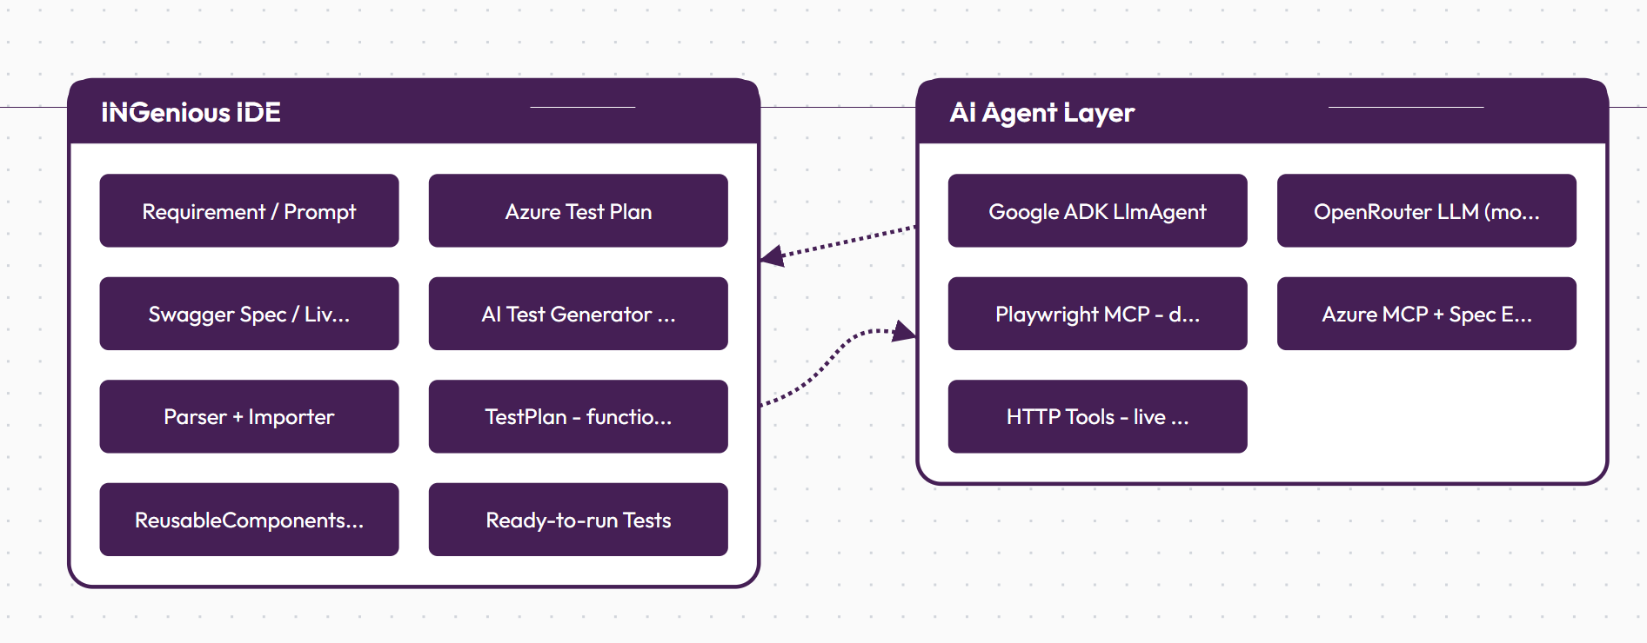
Why Does It Matter?
Stat Cards
Reduction in Manual Effort | Value Created | Faster Cycle Time
~75% | ~$30K / year per QA team | ~6 hrs saved per feature
Test authoring drops from ~30 min to under 7 min per test case | ~80 engineer-hours saved each month, reinvested in coverage and quality | Test creation no longer sits on the release critical path
Basis: a team authoring ~200 test cases/month, manual recording/scripting at ~30 min each vs. AI-assisted review-and-import at ~6 min, blended engineering cost ~$35/hr. Figures scale linearly with team size and test volume.

Quantifiable Benefits
- 75% less manual effort across both web recording and API test scripting.
- Coverage scales without headcount — the same team can produce far more tests per sprint.
- Knowledge reuse — requirements, Azure Test Plans, and API specs are turned directly into tests, so existing documentation finally does double duty.
- Consistency — AI-generated tests follow the same structure every time, with login and setup defined once and reused everywhere.

Alignment & Risks
Alignment
- Builds on the existing INGenious engine and test format — an enhancement, not a rewrite.
- Model-agnostic via OpenRouter — no vendor lock-in, swap LLMs as standards evolve.
- API keys stay in per-project settings — no credentials in code.
Risks & Mitigations
- AI output quality varies by model → built-in validation and recovery fallbacks correct malformed output before import.
- LLM and browser-automation cost → controlled by model choice and prompt caching; reusable components avoid regenerating shared flows.
- Human oversight still needed → generated tests are reviewed and editable before they run — AI accelerates, the tester stays in control.

The Art of the Possible — Broader Vision
Phase 1 — Done (Hackathon)
What we built and proved:
- AI-generated web tests — an agent reads a requirement or Azure Test Plan, explores the live application via Playwright MCP, and produces ready-to-run INGenious tests.
- AI-generated API tests — from a Swagger spec, a live API, or the existing API workbench.
- Reusable components — login and shared setup generated once, referenced everywhere, and not regenerated on later runs.
- Model-agnostic foundation through OpenRouter, with built-in validation and recovery.

Phase 2 — Next (One Sprint)
Hardening and reach:
- Self-healing tests — when a flow changes, the agent re-explores and repairs broken steps instead of a human re-recording.
- Coverage suggestions — the AI proposes missing edge cases and negative scenarios, not just the happy path.
- Bulk generation — point it at a whole Azure Test Plan or full API spec and generate an entire suite in one run.
- Review workflow — a side-by-side diff and approval step so testers accept, edit, or reject generated tests with confidence.

Phase 3 — Future (Production Vision + Scale)
A continuous, organization-wide capability:
- CI/CD-native — tests generated and updated automatically as features merge, keeping coverage in lockstep with code.
- Requirement-to-test traceability — every test linked back to its source requirement or work item for instant audit and impact analysis.
- Beyond web and API — extend the same agent pattern to mobile, database, and end-to-end journeys already supported by INGenious.
- Enterprise scale — a shared, governed test-generation service across teams, with usage controls, model governance, and quality benchmarking built in.
The vision: testing shifts from a manual, after-the-fact task to an intelligent capability that keeps pace with development automatically — letting QA teams focus on strategy and quality, not scripting.

